http://www.hightoken.com/health
Yoga – An Art of Healthy Being and Staying Fit
Yoga is as of now taking its last, most decisive test. Despite the fact that this science goes back numerous many years, it has just as of late go to the West. This is the place Yoga is, no doubt experimentally tried. The Western personality requests come about and confirmation, if none are processed, the framework does not survive And in the western culture the reviews of Var make it possible to stay fit. This is an important methodology and Yoga is right now being put however the rigors of this procedure. So far Yoga is breezing through with no trouble at all. Don't get me wrong, it’s not that the East did not expect that, it’s simply that this methodology channels out the false and negligible approaches, which may overall survive basically in view of superstition and dread, and the East is almost as blissful that this is continuously done as the West. This investigating procedure brings about dividing the stone from the jewels and the jewel that is Yoga is beginning to sparkle however brilliant and clear. In the course of the last three to four decades a lot of exploration has been carried out by the medicinal group and they now, an increasing amount, perceive the safety profits of Yoga. Underneath, I will highlight the main 10 safety profits that Yoga presents and I trust it will motivate ever one to consume this glorious practice is some limit and harvest the rich remunerates as well. A short clarification is given alongside each one profit to help you see better the systems that Yoga utilizes to offer it.
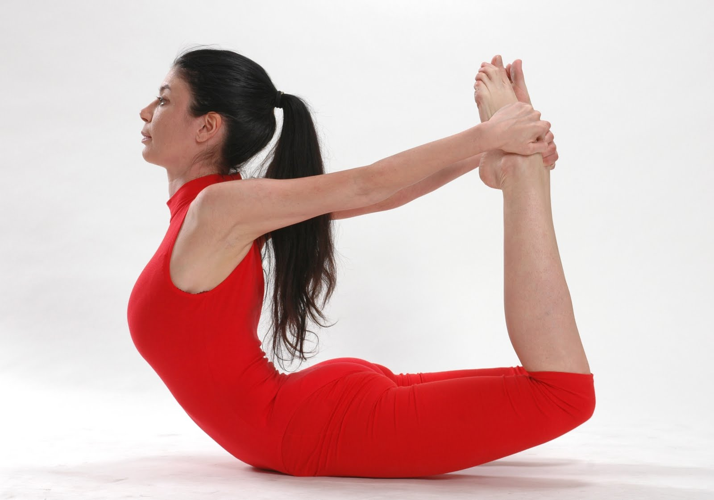

Physical Health Benefits of Yoga:
1. Energy:
Yoga works out, breath control preparing and utilization of yoga body locks all work to enact and parity your vitality pathways, providing for you the essentials and force you have to expand your potential.
2. Quality:
By quality here we don't simply mean physical husky quality, in spite of the fact that that will profit incredibly too because of the unfaltering holding of yoga postures and the activities that yoga joins, additionally the quality of your inner physiological frameworks
3. Mending:
The force of Yoga to mend diseases and cure maladies is getting more a vital a piece of standard medicinal practice and medicine strategies. This capacity of Yoga to recuperate likewise pushes life span.
4. Adaptability:
Yoga postures are maybe the best sort of activities you can do to enhance adaptability. Adaptability is fundamental for dodging wounds and for the strength of the joints, tendons and muscles.
Passionate Health Benefits of Yoga:
5. Peace:
Yoga contemplations and practice system advertises a more terrific mindfulness and energy about the present minute, which smoothest the psyche and permits the peace profound inside to surface.
6. Bliss:
With the developing of a Yoga polish, the excellence and profundity of life get more evident and the spontaneous delight of presence develops.
7. Sympathy:
Yoga qualities and rationality, alongside the act of yoga contemplations, disintegrates one's sense of self-driven actuality, hence creating different mindedness, mindfulness, liberality and empathy.
Mental Health Benefits of Yoga:
8. Mind health:
Yoga breathing activities and yoga reflections create parts of the mind that are typically torpid. When these parts are enacted the force of instinct and additionally other idle forces are unleashed. Moreover, as the mind creates so does your brainpower and clarity of musings.
9. Fixation:
The prerequisite of numerous Yoga contemplations to keep the brain concentrated on a solitary item or mantra (sound vibrations), serves to significantly build your energy of fixation and centered consideration.
10. Mindfulness:
Yoga can essentially be known as the Science of Awareness. This is its basic role. To refine and increment mindfulness with the goal that you can infiltrate the shroud of the normal dualistic personality and experience your Divine Nature inside.

